**DAILY ONLINE ACTIVITIES SUMMARY**

|  |  |  |  |  |  |  |  |  |
| --- | --- | --- | --- | --- | --- | --- | --- | --- |
| **Date:** | **13/06/2020** | | | | | **Name:** | **NAIPUNYA VINOD NAIK** | |
| **Sem & Sec** | **IV SEM & A SECTION** | | | | | **USN:** | **4AL18CS050** | |
| **Online Test Summary** | | | | | | | | |
| **Subject** | | **DATA COMMUNICATION** | | | | | | |
| **Max. Marks** | | **30** | | **Score** | | | **26** | |
| **Certification Course Summary** | | | | | | | | |
| **Course** | **1)WORDPRESS FOR BEGINNERS**  **2) A BEGINNER'S GUIDE TO MICROSOFT EXCEL** | | | | | | | |
| **Certificate Provider** | | | **UDEMY** | | **Duration** | | | 1. **1 HR** 2. **4 HRS** |
| **Coding Challenges** | | | | | | | | |
| **Problem Statement:1)** [Write a C Program to calculate Electricity Bill](https://github.com/orgs/alvas-education-foundation/teams/2nd-year/discussions/116).  2) [How to find the first non repeated character of a given String?](https://github.com/orgs/alvas-education-foundation/teams/cse/discussions/70) | | | | | | | | |
| **Status: EXECUTED** | | | | | | | | |
| **Uploaded the report in Github** | | | | | **YES** | | | |
| **If yes Repository name** | | | | | <https://github.com/naipunya-naik/lockdown-coding/blob/master/C%20CODING/Electricity%20bill_13-06-2020.c>  <https://github.com/naipunya-naik/lockdown-coding/blob/master/JAVA%20CODING/nonrepeated_13-06-2020.java> | | | |
| **Uploaded the report in slack** | | | | | **YES** | | | |

Online Test Details: (Attach the snapshot and briefly write the report for the same).

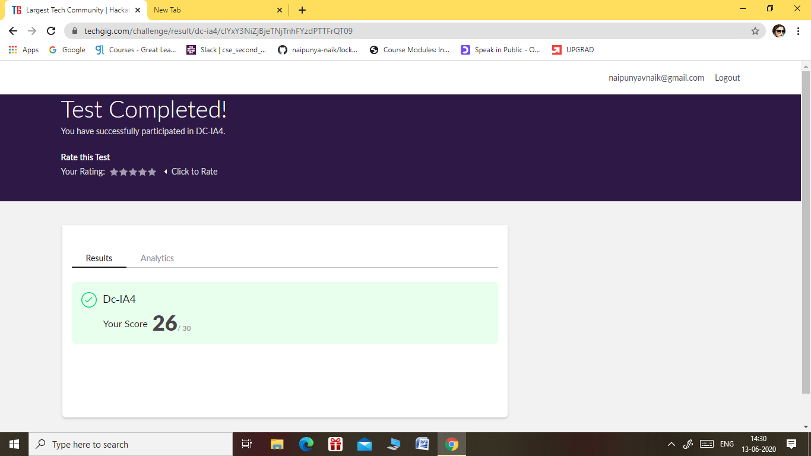

* THE 4TH I.A TEST OF SUBJECT DATA COMMUNICATION WAS CONDUCTED ON 13 JUNE 2020.
* SUBJECT:- DATA COMMUNICATION
* SYLLABUS:- MODULE 1& MODULE 2
* START TIME:- 2.00 PM
* END TIME:- 2.30 PM
* DURATION:- 30 MIN
* NO.OF.QUESTIONS:- 30
* EACH QUESTION CARRIED 1 MARK

Certification Course Details: (Attach the snapshot and briefly write the report for the same).



TODAY, I COMPLETED A CERTIFICATION COURSE ON WORDPRESS FOR BEGINNERS.

I STARTED A NEW COURSE OF **A BEGINNER'S GUIDE TO MICROSOFT EXCEL ON UDEMY PLATFORM.**

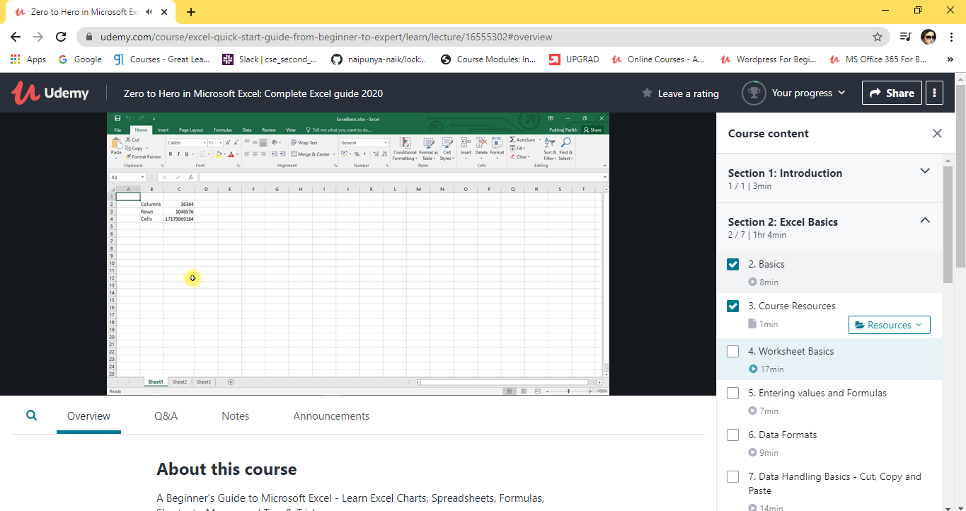

TOPICS LEARNT ON 13 JUNE 2020:-

* BASICS
* COURSE RESOURCES
* WORKSHEET BASICS
* ENTERING VALUES AND FORMULAS
* DATA FORMATS
* DATA HANDLING BASICS
* SAVING AND PRINTING

Coding Challenges Details: (Attach the snapshot and briefly write the report for the same)

PROBLEM STATEMENT 1:- [Write a C Program to calculate Electricity Bill](https://github.com/orgs/alvas-education-foundation/teams/2nd-year/discussions/116)

Top of Form

Bottom of Form

|  |
| --- |
| Given an integer U denoting the amount of KWh units of electricity consumed, the task is to calculate the electricity bill with the help of the below charges: • 1 to 100 units – Rs 10/- Per Unit • 100 to 200 units – Rs. 15/- Per Unit • 200 to 300 units – Rs. 20/- Per Unit • above 300 units – Rs. 25/- Per Unit  **Examples:**  Input: U = 250  Output: 3500  **Explanation:**  Charge for the first 100 units – 10100 = 1000Charge for the 100 to 200 units – 15100 = 1500 Charge for the 200 to 250 units – 20*50 = 1000 Total Electricity Bill = 1000 + 1500 + 1000 = 3500 |

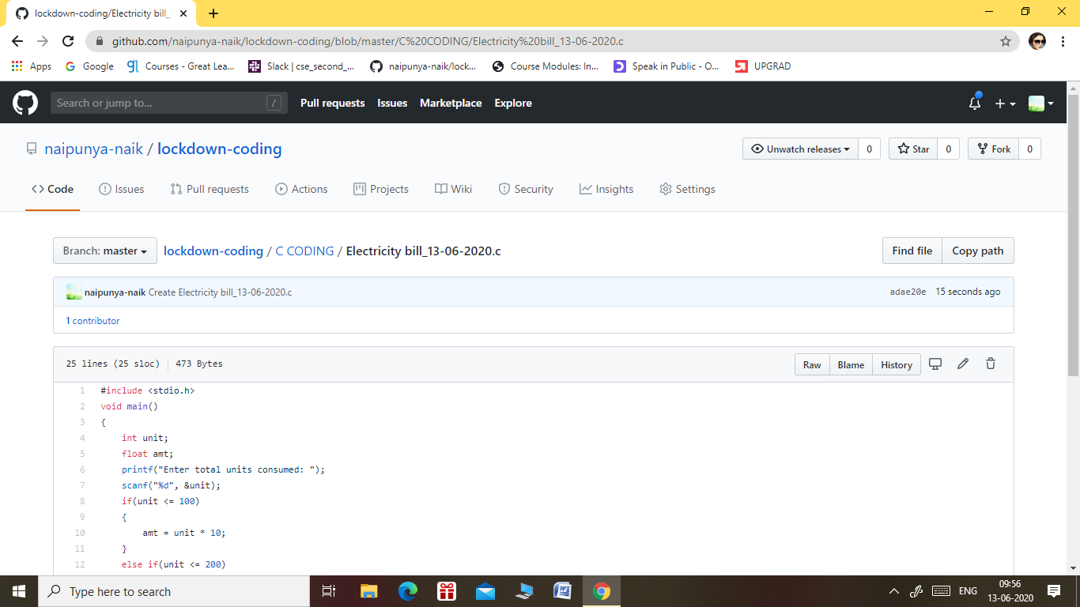

GITHUB REPOSITORY LINK:-

<https://github.com/naipunya-naik/lockdown-coding/blob/master/C%20CODING/Electricity%20bill_13-06-2020.c>

PROBLEM STATEMENT 2:-

[How to find the first non repeated character of a given String?](https://github.com/orgs/alvas-education-foundation/teams/cse/discussions/70)

Top of Form

Bottom of Form

|  |
| --- |
| Use Java and refer net |

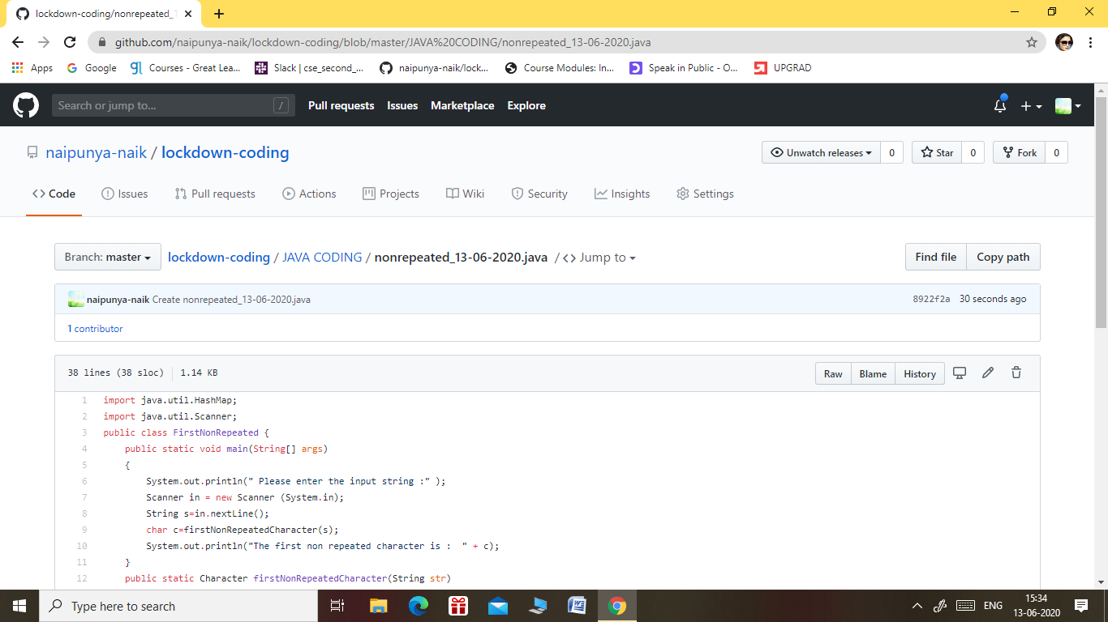

GITHUB REPOSITORY LINK:-

<https://github.com/naipunya-naik/lockdown-coding/blob/master/JAVA%20CODING/nonrepeated_13-06-2020.java>